|  |  |  |
| --- | --- | --- |
| C(1) | C(0) | HEX0(0) |
| 0 | 0 | 1 |
| 0 | 1 | 0 |
| 1 | 0 | 1 |
| 1 | 1 | 1 |

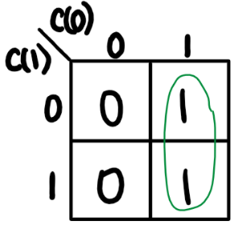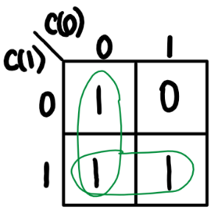

HEX0(1) = c(0)

HEX0(0) = c(1) + c(0)’

|  |  |  |
| --- | --- | --- |
| C(1) | C(0) | HEX0(1) |
| 0 | 0 | 0 |
| 0 | 1 | 1 |
| 1 | 0 | 0 |
| 1 | 1 | 1 |



HEX0(2) = c(0)

|  |  |  |
| --- | --- | --- |
| C(1) | C(0) | HEX0(2) |
| 0 | 0 | 0 |
| 0 | 1 | 1 |
| 1 | 0 | 0 |
| 1 | 1 | 1 |

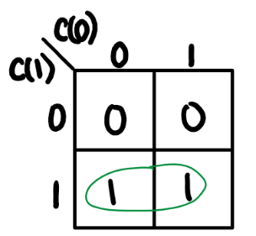

HEX0(3) = c(1)

|  |  |  |
| --- | --- | --- |
| C(1) | C(0) | HEX0(3) |
| 0 | 0 | 0 |
| 0 | 1 | 0 |
| 1 | 0 | 1 |
| 1 | 1 | 1 |

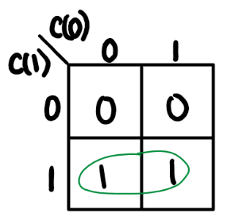

HEX0(4) = c(1)

|  |  |  |
| --- | --- | --- |
| C(1) | C(0) | HEX0(4) |
| 0 | 0 | 0 |
| 0 | 1 | 0 |
| 1 | 0 | 1 |
| 1 | 1 | 1 |

|  |  |  |
| --- | --- | --- |
| C(1) | C(0) | HEX0(5) |
| 0 | 0 | 1 |
| 0 | 1 | 0 |
| 1 | 0 | 1 |
| 1 | 1 | 1 |



HEX0(4) = c(1)

HEX0(5) = c(1) + c(0)’

|  |  |  |
| --- | --- | --- |
| C(1) | C(0) | HEX0(6) |
| 0 | 0 | 0 |
| 0 | 1 | 0 |
| 1 | 0 | 1 |
| 1 | 1 | 1 |